FSJ Award Requirements

January 17, 2018

Authors: Jacqueline Forest, Jonah Cowan, Pierre (Shu-Jun) Lin, Dave Kotowicz

**Project Description**

Students at the Faculty St Jean may be eligible for awards/scholarships. Today, they have access to every award, even ones they are not eligible for. This creates confusion and/or difficulty in determining which may apply to the student, and students may apply for awards for which they are ineligible. This creates strain on the award coordinator, as it is necessary to sift through all applications to verify eligibility prior to submission for review. This system will be a stand-alone system that enables the coordinator to pre-filter the awards for which a student is eligible to apply based on their program. The result is far fewer awards appear to the student, they are able to easily assess their eligibility and apply, and this reduces the workload on the coordinator in confirming eligibility prior to the review process.

### Glossary

* Adjudicator: An alternate term for an Adjudicator Committee Member.
* Adjudicator Committee: Staff who will review Student Award applications to assess eligibility and made recommendations for awarding the Award. Appointed by the Awards Coordinator.
* Adjudicator Committee Member: A member of the Adjudicator Committee.
* Admin: another term for Awards Coordinator.
* Award: a resource available to Students, which has eligibility criteria.
* Awards Committee: An alternate term for the Adjudicator Committee.
* Awards Committee Member: An alternate term for an Adjudicator Committee Member.
* Awards Coordinator: the staff responsible for creating Awards for Students to apply for, screening completed Awards for eligibility, and assignment to a member of the Adjudication Committee.
* Recipient: An alternate term for a Student.
* Student: the role of user who will be filling out an application for an Award.

**UI Navigation, Page Mockups and DescriptionsBottom of Form**

NOTE:

* All headers contain a logout option (not including sub-windows) and a link to allow for the user to edit their information

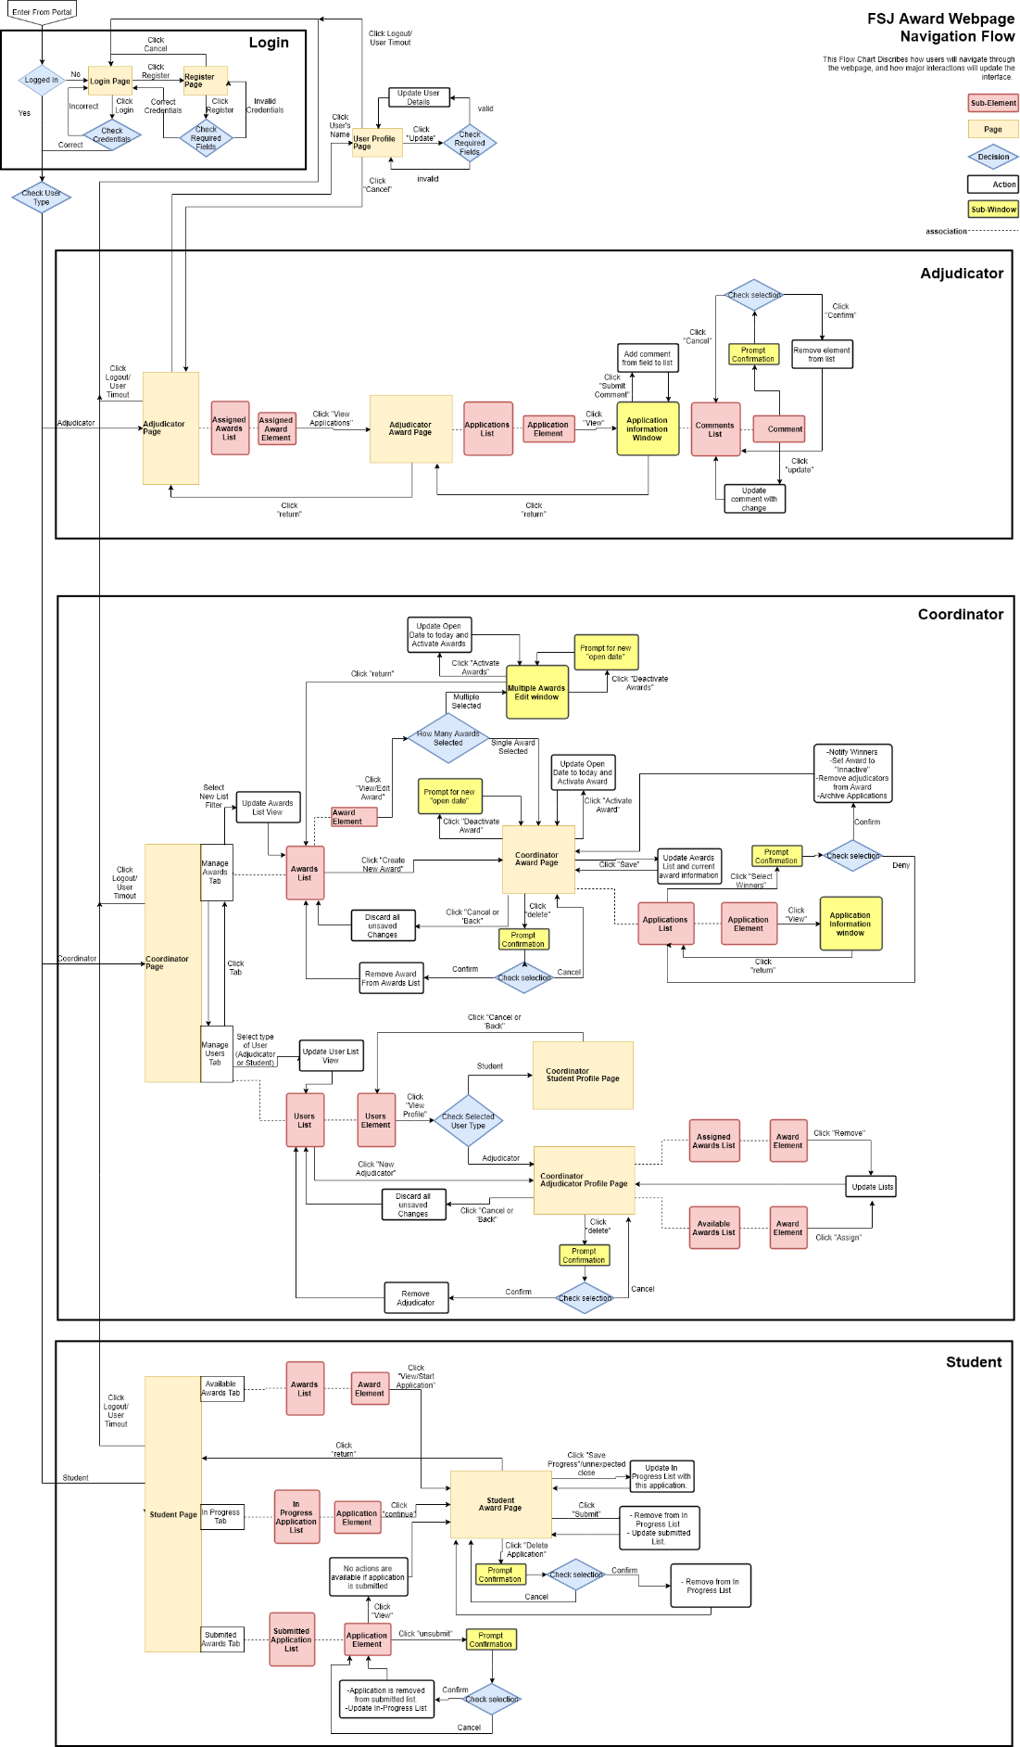**Navigation Diagram:**

## Login Section:

### Login Page:

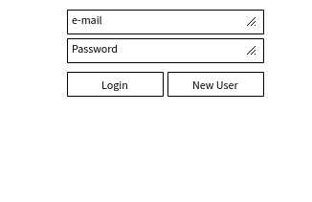

* The Login Page is where a user will land after following a link to this website or after they log out of their account.
* The Page contains two text fields used for logging in:
  + Email
  + Password
* The Page contains two buttons:
  + Login: checks the text fields and logs the user in appropriately
  + Register: Sends the user to the "Register Page

### Register Page

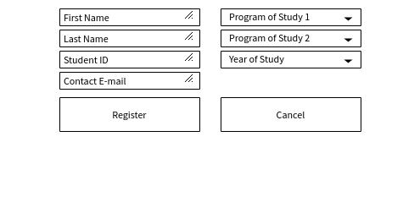

* Contains text fields for registration of a new account:
  + First Name
  + Last Name
  + Student ID
  + E-mail
  + Year of study
  + (more could be added)
* A drop-down menu will display all available programs
  + Field 1: used by everyone
  + Field 2: to be used by prospective students
* 2 buttons
  + Register (checks credentials and acts appropriately)
  + Cancel (returns to login screen with nothing changed)

## Adjudicator Section:

### Adjudicator Home Page

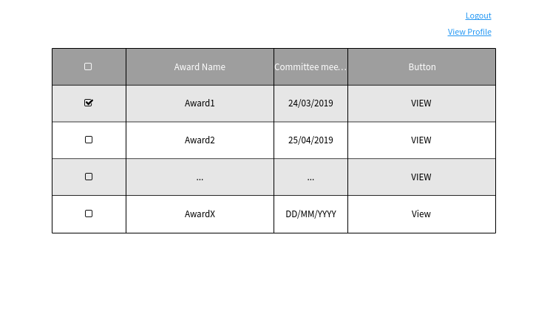

* Contains a list of all the Awards that have been assigned to this adjudicator.
* Every element of this list, contains the:
  + Name of the Award
  + Date of committee meeting (?)
  + Button to View the Awards Details (Brings user to the Adjudicator Award Page)

### Adjudicator Award Page

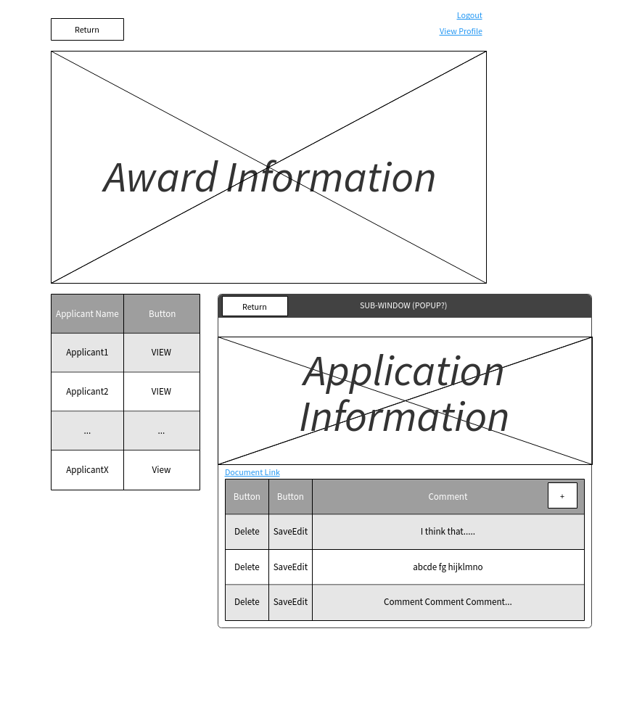

* Contains a "return" button, linking to Adjudicator Home Page.
* Contains All the information about the award associated with the page.
* Contains a list of applications for the given reward.
* Every element of the list contains:
  + The name of the applicant
  + A button to view the Applications details (opens a sub-window that displays all information of the application)
    - In turn this window will include:
      * A link to any of the applicants submitted document.
      * All the information included in the application.
      * A list of the current adjudicators existing comments
      * The elements of this list should include a editable text field of the comment itself, an ability to delete the comment, or to save any changes to it.
      * An empty text field prompts the adjudicator for a new comment, a button beside this allows this comment to be saved to the list of comments.
      * A button to return to the Adjudicator Award Page.

## Coordinator Section:

The Coordinator is immediately presented with two tabs, the Manage Awards Tab, and the Manage Users Tab. By clicking on one or the other the Coordinator can easily switch between major responsibilities.

### Manage Awards Tab

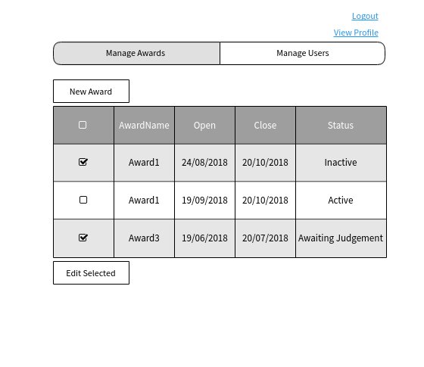

* The coordinator is presented with a list of all awards which are assigned types: Active, Inactive, or Awaiting Judgement.
* This list has a drop-down menu that allows for various filters (TBD)
* This list’s elements contain the award's:
  + Name
  + Open/close dates
  + Status (Active, Inactive, Awaiting Judgement)
  + A check box to select the award
* The page includes a button to create a new award (this will go to the Coordinator Award Page, with no fields filled in).
* A button to edit all selected awards.
  + If more than one is selected the Multiple Awards Sub-Window is opened.
    - This window allows for the mass activation, and deactivation of awards.
    - This also allows for the mass changing of Start/End dates of awards.
    - Start Dates should be allowed to be set to none, so as to allow for only manual activation.
  + If only one award is selected the Coordinator Award Page is opened to allow for detailed editing of the award.

### Coordinator Award Page

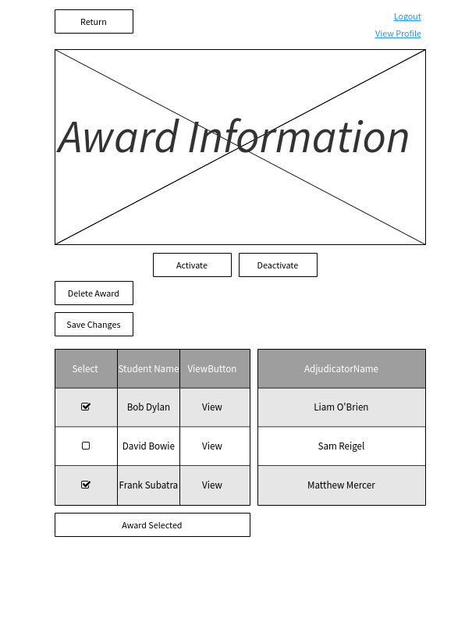

* Displays all information about a specific award:
  + Description of award
  + Amount earned if award is won
  + Requirements
  + The sponsor
  + If the award requires an attachment and what that is
  + Open/close dates
* Buttons allow the coordinator to activate, deactivate the award right now or delete the award.
* A button allows an award to be saved for later, placing it in the Awards list, from the Manage Awards Tab
* There is a list that shows all current applications to the award
  + Shows name of the Student
  + Has a button to view the application in a sub window
    - Shows all information about the application and the attached documents can be viewed, but not downloaded.
    - Has a button to return to the award page
  + Every application has a check box on it
  + A button "select Winners" awards the award to all selected applicants
    - Notifies winners
    - Sets the Award to inactive
    - Removes adjudicators from the award
    - Archives the applications
* There is a list that shows current adjudicators for the award
* A return button to move to the previous screen

### Manage Users Tab

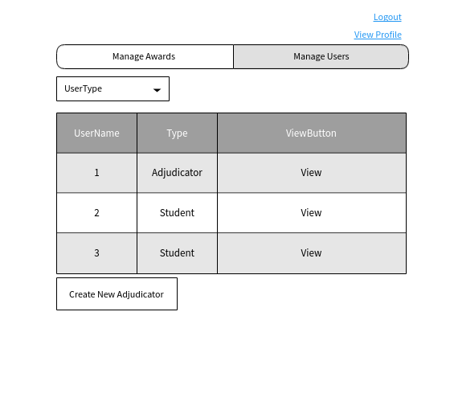

* Contains a list of all Users in the system
* This list can be filtered by Adjudicator or Student
* Every element of the list contains the name of the User and their user type as well as a button to view profile.
* View Profile buttons bring to the Coordinators view of the user (Student Profile Page or Adjudicator Profile Page)
* A button exists to create a new Adjudicator

### Coordinator Adjudicator Profile Page

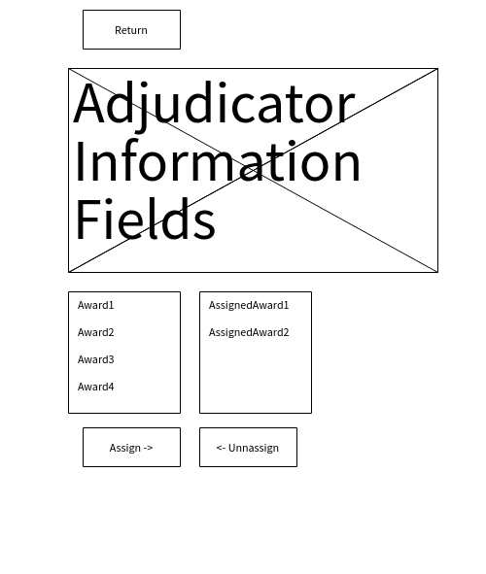

* Contains all information about an adjudicator (this information is blank on a new adjudicator and can be edited by the coordinator or adjudicator after they have access to their page):
  + Name
  + E-mail
  + Possibly more to be added
* Shows two parallel lists, one of this adjudicator’s assigned awards and one of awards that can be assigned.
* Buttons exist to move awards between the two lists
* Adjudicators’ profiles can be deleted from a button here.
* "Return" button moves back to the Manage Users Tab.

### Coordinator Student Profile Page

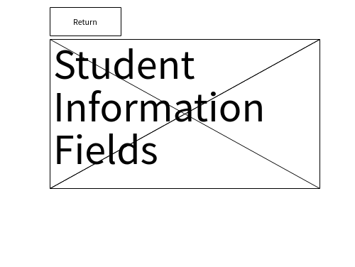

* This contains all information about a student’s profile (name, email, student id, year, program, possibly more to be added)
* Exact Functionality of this page is to be determined.
* Contains a button to return to Manage Users Tab

## Student Section:

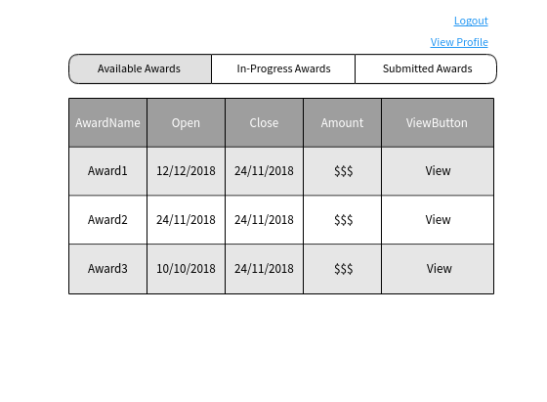

* The student is given three tabs: in-progress awards, available awards, submitted awards.

### Available Awards Tab

* Has a list of all awards that the student is eligible to apply for based on their profile
* List contains:
  + Name of the award
  + The Open/Close date of the awards
  + Amount it is possible to receive
  + A button to see further details on an award (moves Student Award Page)

### In Progress Awards Tab

* Has a list of all awards that the student has saved an application for but not submitted
* List contains:
  + Name of the award
  + The Open/Close date of the awards
  + Amount it is possible to receive
  + A button to see further details on an award (moves Student Award Page)

### Submitted Awards Tab

* Has a list of all awards that the student has submitted
* List contains:
  + Name of the award
  + The Open/Close date of the awards
  + Amount it is possible to receive
  + A button to see further details on an award (moves to Student Award Page)
* Has an option to "un-submit" an award and move it back to the in-progress tab

### Student Award Page

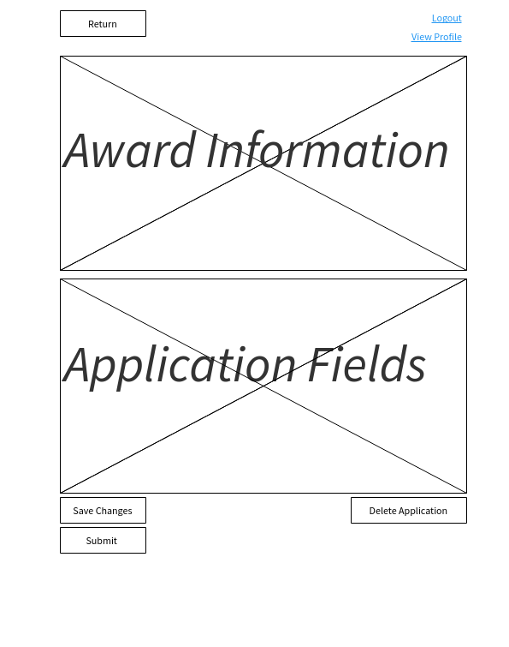

* Shows all information about the award and provides fields for the Student to enter their application information
* The attachment section is only shown if the coordinator has allowed attachments
* Only 1 attachment is allowed via an import button
* If the Award is already submitted by the student, they may view this information but not edit it.
* Click "return" sends the user back to the student home page and does not save information, if no information is added to the fields the award is not sent to the in-progress list.
* Click "save" sends this award to the in-progress list and saves the information in the fields.
* Any closing of the browser without using the return button will do the same as the save button.
* Submit button, sends this award to the submitted list.
* "Delete Application" button allows the application to be removed from the in-progress list.

**User Stories**

**Student user stories**

1: As a Student, I want to be able to create an account

* 1.1: As a student, I want to be able to create an account using enter my name, my student ID, my U of A email address and my program
* 1.2: As a student, if I am a prospective student, I want to be able to enter two programs when making an account
* 1.3: As a student, if I am a current student, I will only be able to enter one program
* 1.4: As a student, I want to be able to update my year of study in my profile

2: As a Student, I want to be able to see all the awards I can apply to

* 2.1: As a student, I want to only be able to see awards that are appropriate for my program or future programs
  + 2.1.1: As a student, I want to be able to see awards if the deadline for the award has not passed
* 2.2: As a student, I want to be able to see which awards I have applied to, which awards for which I have not yet completed my application, and which awards I have not yet applied to

3: As a student, I want to be able to apply to awards

* 3.1: As a student, I want to be able to have my incomplete applications saved if I decide to close the session
* 3.2: As a student, I want to be able to attach all my required documents as a single document if the application requires documents
* 3.3: As a student, I don’t want to have the option to attach documents if the application does not require documents
* 3.4: As a student, I want to be able to submit my application for an award after I am done with the application process

4: As a student, I want to be able to cancel my application before the deadline of the award

* 4.1: As a student, I don't want the option to cancel my application if the deadline has passed

5: As a student, I want to be notified if I have received an award

* 5.1: As a student, I don’t want to be notified if I did not receive an award

6: As a student, I want to be able to log in to my account if I have previously created one

* 6.1: As a student, I want to have a reasonable level of security for my log in credentials

**Awards Coordinator user stories**

1: As a coordinator, I want to add new awards.

* 1.1 As a coordinator, I want to be able to enter a new award’s name, description, amount, program requirements, additional requirements (in text format), open/close date, and document upload requirements (at most one per award).
* 1.2 As a coordinator, I want awards that I finalize to persist indefinitely.
* 1.3 As a coordinator, I want to be able to cancel in the middle of adding an award and have nothing save.
* [Non-MVP] 1.4 As a coordinator, I want to be able to save my progress for an award I’m currently working on and come back to finalize it later.
* [Non-MVP] 1.5 As a coordinator, I want awards that I have finalized to disappear from my in-progress workspace.

2: As a coordinator, I want to edit awards.

* 2.1 As a coordinator, I want to be able to edit any award.
* 2.2 As a coordinator, I want to be able to change an award’s name, description, amount, program requirements, additional requirements, open/close date, and document upload requirements.
* 2.3 As a coordinator, I want changes that I save to persist indefinitely.
* [Non-MVP] 2.4 As a coordinator, I want to be able to save my progress for an award I am editing and come back to it later.
* [Non-MVP] 2.5 As a coordinator, I want awards I have finished editing and finalized to disappear from my in-progress workspace.

3: As a coordinator, I want to delete awards.

* 3.1 As a coordinator, I want awards I delete to be permanently deleted.
* 3.2 As a coordinator, when I delete an award I want all applications for that award to be deleted.

4: As a coordinator, I want to access all information in the system.

* 4.1 As a coordinator, I want to be able to access all student profiles.
* 4.2 As a coordinator, I want to be able to access all adjudicator profiles.
  + 4.2.1 As a coordinator, I want to see which adjudicators are assigned to which awards.
* 4.3 As a coordinator, I want to be able to view all awards.
* 4.4 As a coordinator, I want to be able to view all applications for an award.
* 4.5 As a coordinator, I want to be able to view all adjudicator comments on an application.

5: As a coordinator, I want to activate and deactivate awards.

* 5.1 As a coordinator, I want to select a group of awards and manually open them at once.
* [Non-MVP] 5.2 As a coordinator, I want to select a group of awards and set a date for them to open automatically.
* 5.3 As a coordinator, I want to select a group of awards and manually close them at once.
* [Non-MVP] 5.4 As a coordinator, I want to select a group of awards and set a date for them to close automatically.
* 5.5 As a coordinator, I want applications to be enabled for all open awards.
* 5.6 As a coordinator, I want applications to be disabled for all closed awards.
* 5.7 As a coordinator, I want to deactivate, edit and reactivate awards.
* [Non-MVP] 5.8 As a coordinator, I want to be able to view all groups of awards, including groups for which I have set an automatic open or close.

6: As a coordinator, I want to create and delete adjudicators.

* 6.1 As a coordinator, I want to create new adjudicator profiles.
* 6.2 As a coordinator, I want to assign adjudicators to an award or group of awards.
* 6.3 As a coordinator, I want to view all comments that the adjudicators add to applications.
  + 6.3.1 As a coordinator, I want to be able to consolidate or print a list of all comments that adjudicators have added to an application.
* 6.4 As a coordinator, I want to delete adjudicators after the committee meetings.
* 6.5 As a coordinator, I want to edit an adjudicator’s profile

7: As a coordinator, I want to select recipients of an award.

* 7.1 As a coordinator, I want recipients of an award to automatically be notified.
* 7.2 As a coordinator, I want students who applied for an award and were rejected not to be notified.

**Adjudication Committee user stories**

1: As an awards committee member, I want to be able to view awards assigned to me

* 1.1: As an awards committee member, I want to be able to view a list of applications for a given award
* 1.2: As an awards committee member, I want to be able to view a single application for a given award in detail, including any attached document

2: As an awards committee member, I want to be able to comment (one comment) on an award application

* 2.1: As an awards committee member, I want to be able to create a comment on an award application
* 2.2: As an awards committee member, I want to be able to modify my comment on an award application
* 2.3: As an awards committee member, I want to be able to delete my comment on an award application

### System user stories

The system at large requires some behaviour that is not tied to any one specific role. Information related to expected system behaviour is captured in this section.

1: As the system, I want all applications to an award to be either preserved for a certain amount of time after the award has closed or exported to another format for retention and review (where necessary). [Double check this]

2: As the system, I want all users who register to register using their UAlberta email address.

3: As the system, I want to notify students who are awarded an award via their UAlberta email address.

4: As the system, I want to be able to be translated into another language.

5: As the system, I want users who are inactive to automatically be logged out / timed out after some period of time.

**Similar Products**

* The existing Faculty St Jean Awards system.
* BearTracks Awards through the University of Alberta.